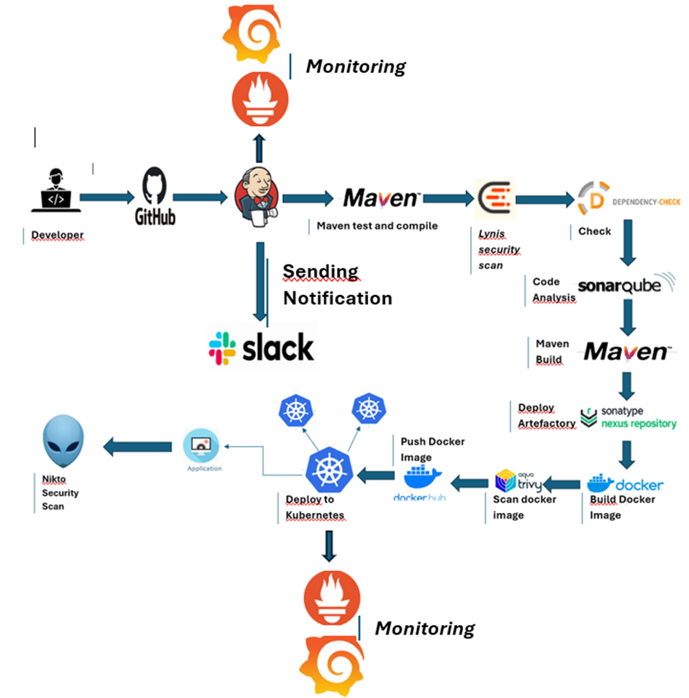COMPLETE CI/CD PROJECT DEVSECOPS

**Project GitHub Repo**- : <https://github.com/eyaboubaker/Devscops.git>

We need four servers for our today’s Project

**Jenkins Server-** On this Server, Jenkins will be installed with some other tools such as sonarqube,sonatype nexus,Lynis,trivy, ,Nikto, Prometheus, Node Exporter, and Grafana.

**Kubernetes Master Server-** This Server will be used as the Kubernetes Master Cluster Node which will deploy the applications on worker nodes.

**Kubernetes Worker1 Server-** This Server will be used as the Kubernetes Worker1 Node on which the application will be deployed by the master node.

**Kubernetes Worker2 Server-** This Server will be used as the Kubernetes Worker2 Node on which the application will be deployed by the master node.

Let’s create the following instances.

**Jenkins Server**

Ubuntu OS 22.04 version.

8GB ram

30GB Disk

**Kubernetes Master & Worker Node**

We have to create two Kubernetes Nodes which need at least 2 CPUs. Log in to the Jenkins Server(Devscops)

Install jenkins

# Installing Java

sudo apt update -y

sudo apt install fontconfig openjdk-17-jre -y

java –version

# Installing Jenkins

sudo wget -O /usr/share/keyrings/jenkins-keyring.asc \

https://pkg.jenkins.io/debian-stable/jenkins.io-2023.key

echo deb [signed-by=/usr/share/keyrings/jenkins-keyring.asc] \

https://pkg.jenkins.io/debian-stable binary/ | sudo tee \

/etc/apt/sources.list.d/jenkins.list > /dev/null

sudo apt update

sudo apt install jenkins -y

sudo systemctl enable jenkins

sudo ufw allow 8080/tcp

sudo ufw reload

Check the status of the Jenkins server

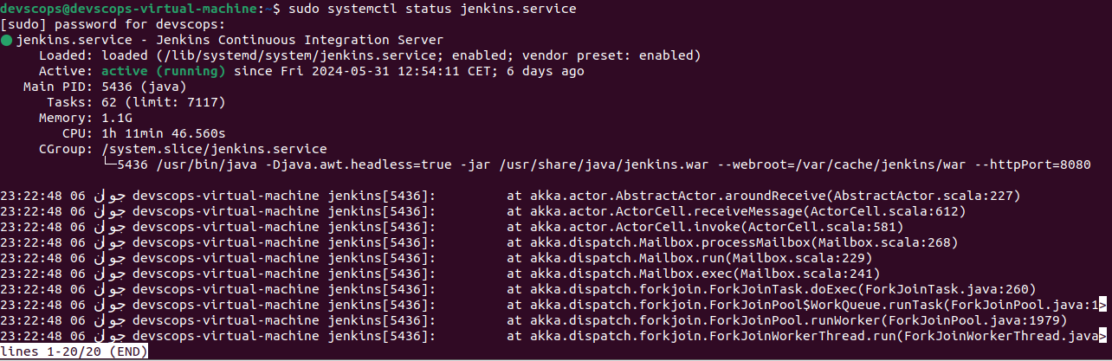

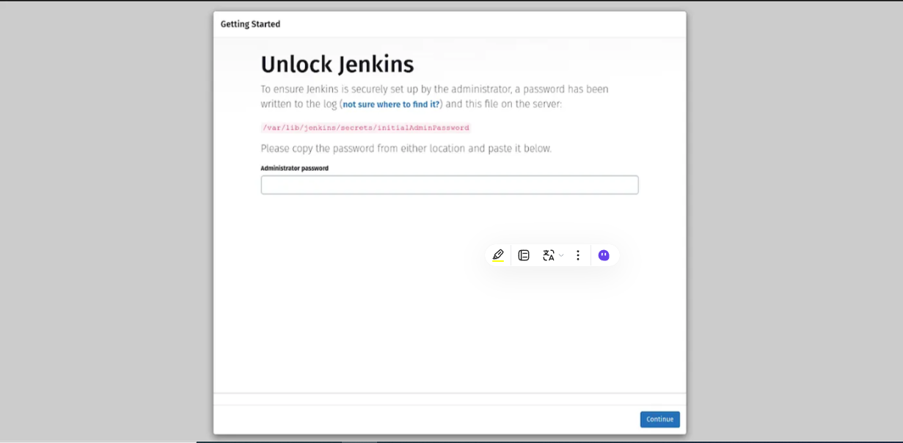Copy your Jenkins Server Public IP and paste it into your favorite browser with port number 8080.

Run the command on your Jenkins server

sudo cat /var/lib/jenkins/secrets/initialAdminPassword

Click on the **Install suggested plugins**

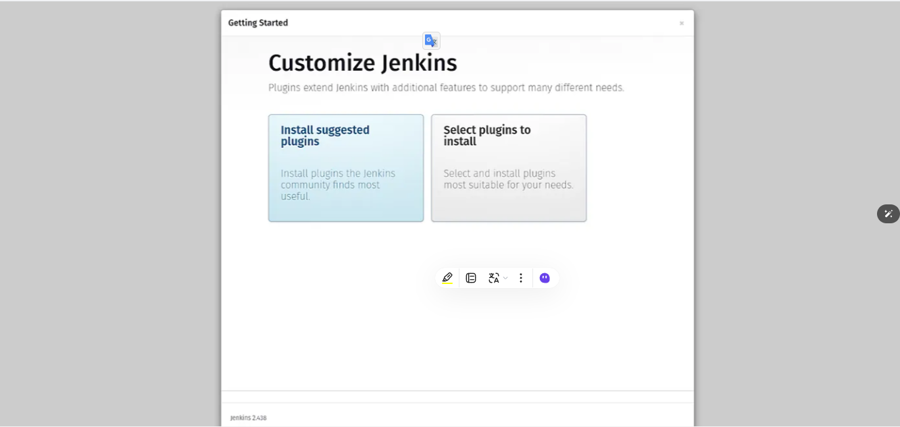

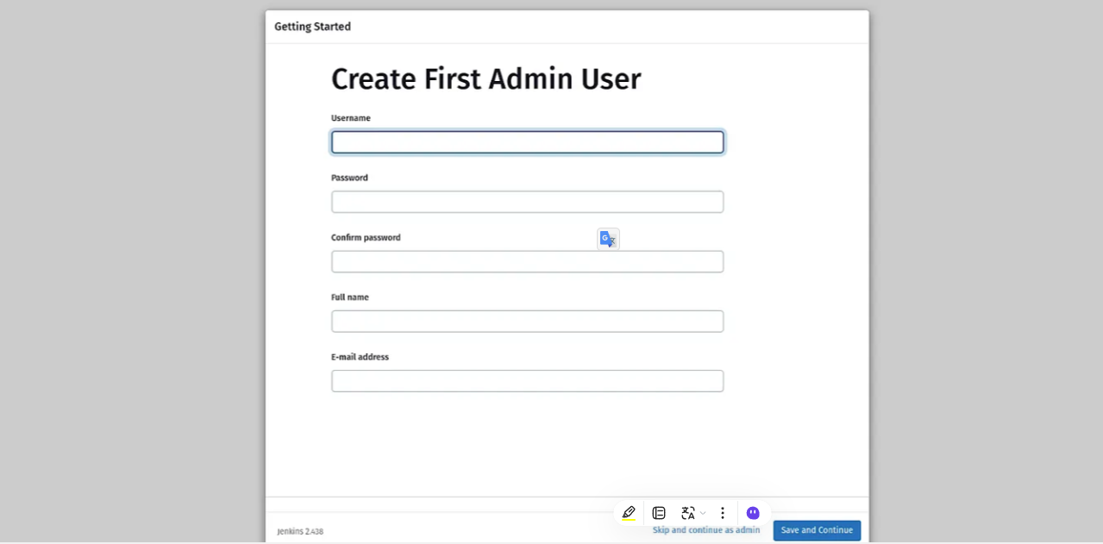Click on the **Skip and continue as admin**

Install Docker and configure on the **Jenkins Server**

1. sudo apt install apt-transport-https ca-certificates curl software-properties-common
2. curl -fsSL https://download.docker.com/linux/ubuntu/gpg | sudo gpg --dearmor -o /usr/share/keyrings/docker-archive-keyring.gpg
3. echo "deb [arch=$(dpkg --print-architecture) signed-by=/usr/share/keyrings/docker-archive-keyring.gpg] https://download.docker.com/linux/ubuntu $(lsb_release -cs) stable" | sudo tee /etc/apt/sources.list.d/docker.list > /dev/null
4. sudo apt update
5. apt-cache policy docker-ce
6. sudo apt install docker-ce
7. sudo systemctl status docker
8. sudo usermod -aG docker jenkins
9. sudo chmod 666 /var/run/docker.sock

Install git

1. sudo apt install git-all
2. git –version

Install Trivy

1. sudo apt-get install wget apt-transport-https gnupg lsb-release

2- wget -qO - https://aquasecurity.github.io/trivy-repo/deb/public.key | sudo apt-key add -

3- echo deb https://aquasecurity.github.io/trivy-repo/deb $(lsb_release -sc) main | sudo tee -a /etc/apt/sources.list.d/trivy.list

4- sudo apt-get update

5- sudo apt-get install trivy

6- sudo apt install mlocate

7- sudo apt install colorized-logs

Install Lynis

1- echo "deb https://packages.cisofy.com/community/lynis/deb/ stable main" | sudo tee /etc/apt/sources.list.d/cisofy-lynis.list

2- wget -O - https://packages.cisofy.com/keys/cisofy-software-public.key | sudo apt-key add -

3- sudo apt update

4- sudo apt install lynis

5- lynis show version

6- sudo lynis audit system

Install Nikto

1- sudo apt install nikto

2- nikto -h example.com

Install Sonarqube on your **Jenkins Server**

1- sudo sysctl -w vm.max_map_count=262144

2- sudo sysctl -w fs.file-max=65536

3-ulimit -n 65536

4-ulimit -u 4096

5- sudo apt-get update

6- sudo apt-get install openjdk-17-jdk -y

7-sudo apt-get install openjdk-17-jre -y

8- sudo apt install dirmngr ca-certificates software-properties-common apt-transport-https lsb-release curl -y

9-curl -fSsL https://www.postgresql.org/media/keys/ACCC4CF8.asc | gpg --dearmor | sudo tee /usr/share/keyrings/postgresql.gpg > /dev/null

10-sudo apt install postgresql-client-15 postgresql-15

11-systemctl status postgresql

12-sudo systemctl enable postgresql

13-sudo passwd postgres

14-su - postgres

15-psql

16-ALTER USER sonar WITH ENCRYPTED password 'sonar';

17-CREATE DATABASE sonarqube OWNER sonar;

18-grant all privileges on DATABASE sonarqube to sonar;

19-\q

20-sudo wget https://binaries.sonarsource.com/Distribution/sonarqube/sonarqube-9.9.4.87374.zip

21-sudo unzip sonarqube-9.9.4.87374.zip -d /opt

22-sudo mv /opt/sonarqube-9.9.4.87374 /opt/sonarqube

23-cd /opt/sonarqube

24-sudo groupadd sonar

25-sudo useradd -c "user to run SonarQube" -d /opt/sonarqube -g sonar sonar

26-sudo chown sonar:sonar /opt/sonarqube -R

27-sudo nano /opt/sonarqube/conf/sonar.properties

sonar.jdbc.username=sonar

sonar.jdbc.password=sonar

sonar.jdbc.url=jdbc:postgresql://localhost:5432/sonarqube

28- sudo nano /opt/sonarqube/bin/linux-x86-64/sonar.sh

RUN_AS_USER=sonar

29-sudo nano /etc/systemd/system/sonar.service

[Unit]

Description=SonarQube service

After=syslog.target network.target

[Service]

Type=forking

ExecStart=/opt/sonarqube/bin/linux-x86-64/sonar.sh start

ExecStop=/opt/sonarqube/bin/linux-x86-64/sonar.sh stop

User=ddsonar

Group=ddsonar

Restart=always

LimitNOFILE=65536

LimitNPROC=4096

[Install]

WantedBy=multi-user.target

30- sudo systemctl enable sonar

31- sudo systemctl start sonar

32- sudo systemctl status sonar

Now, copy your Public IP of Jenkins Server and add 9000 Port on your browser. The username and password will be admi

Install Nexus on your **Jenkins Server**

1- sudo apt-get update

2-sudo apt install openjdk-8-jre-headless

3-cd /opt

4-sudo wget https://download.sonatype.com/nexus/3/latest-unix.tar.gz

5-sudo tar -zxvf latest-unix.tar.gz

6-sudo mv /opt/nexus-3.30.1-01 /opt/nexus

7-sudo adduser nexus

8-sudo visudo

9-nexus ALL=(ALL) NOPASSWD: ALL

10-sudo chown -R nexus:nexus /opt/nexus

11-sudo chown -R nexus:nexus /opt/sonatype-work

12-sudo nano /opt/nexus/bin/nexus.rc

13-run_as_user="nexus"

14-sudo nano /etc/systemd/system/nexus.service

[Unit]

Description=nexus service

After=network.target

[Service]

Type=forking

LimitNOFILE=65536

ExecStart=/opt/nexus/bin/nexus start

ExecStop=/opt/nexus/bin/nexus stop

User=nexus

Restart=on-abort

[Install]

WantedBy=multi-user.target

15-sudo systemctl start nexus

16-sudo systemctl enable nexus

17-sudo systemctl status nexus

18- sudo ufw allow 8081/tcp

19-cat /opt/sonatype-work/nexus3/admin.password

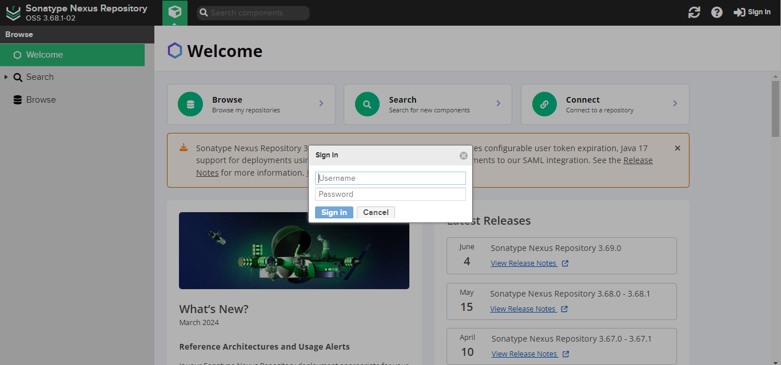

Install and Configure the Prometheus, Node Exporter, and Grafana

* Prometheus

1- sudo useradd \

--system \

--no-create-home \

--shell /bin/false prometheus

2- sudo wget https://github.com/prometheus/prometheus/releases/download/v2.32.1/prometheus-2.32.1.linux-amd64.tar.gz

3- sudo tar -xvf prometheus-2.32.1.linux-amd64.tar.gz

4- sudo mkdir -p /data /etc/prometheus

5- cd prometheus-2.32.1.linux-amd64

6- sudo mv prometheus promtool /usr/local/bin/

7- sudo mv consoles/ console_libraries/ /etc/prometheus/

8- sudo mv prometheus.yml /etc/prometheus/prometheus.yml

9- sudo chown -R prometheus:prometheus /etc/prometheus/ /data/

10- cd

sudo rm -rf prometheus*

11- prometheus --version

12- prometheus --help

13- sudo nano /etc/systemd/system/prometheus.service

[Unit]

Description=Prometheus

Wants=network-online.target

After=network-online.target

StartLimitIntervalSec=500

StartLimitBurst=5

[Service]

User=prometheus

Group=prometheus

Type=simple

Restart=on-failure

RestartSec=5s

ExecStart=/usr/local/bin/prometheus \

--config.file=/etc/prometheus/prometheus.yml \

--storage.tsdb.path=/data \

--web.console.templates=/etc/prometheus/consoles \

--web.console.libraries=/etc/prometheus/console_libraries \

--web.listen-address=0.0.0.0:9090 \

--web.enable-lifecycle

[Install]

WantedBy=multi-user.target

14- sudo systemctl enable prometheus

15- sudo systemctl start prometheus

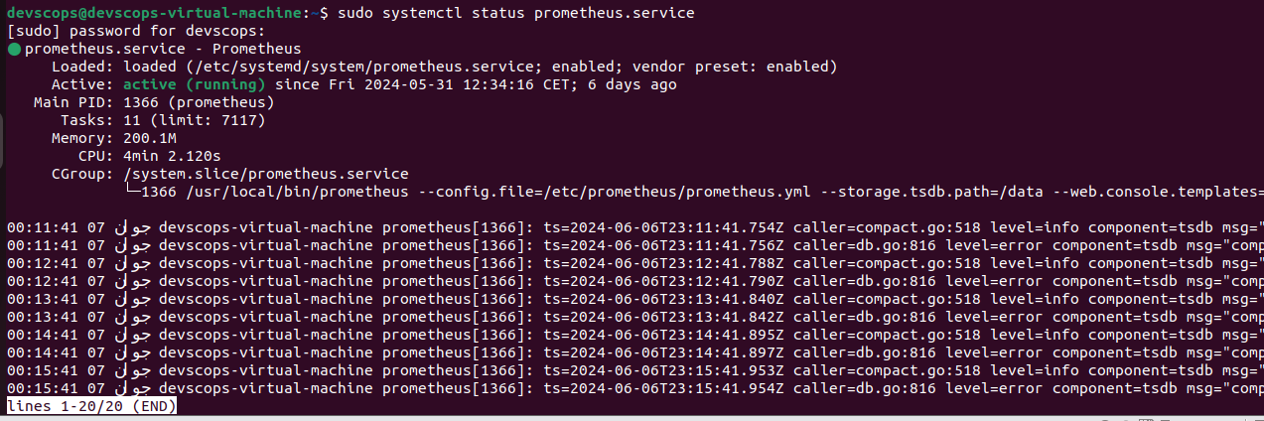16- sudo systemctl status prometheus

Once the Prometheus service is up and running then, copy the public IP of your **machine** and paste it into your favorite browser with a 9090 port.

Now, we have to install a node exporter to visualize the machine or hardware level data such as CPU, RAM, etc on our Grafana dashboard.

Node Exporter

1- sudo useradd \

--system \

--no-create-home \

--shell /bin/false node_exporter

2- sudo wget https://github.com/prometheus/node_exporter/releases/download/v1.3.1/node_exporter-1.3.1.linux-amd64.tar.gz

3- sudo tar -xvf node_exporter-1.3.1.linux-amd64.tar.gz

4- sudo mv \

node_exporter-1.3.1.linux-amd64/node_exporter \

/usr/local/bin/

5- rm -rf node_exporter*

6- node_exporter --version

7- sudo nano /etc/systemd/system/node_exporter.service

[Unit]

Description=Node Exporter

Wants=network-online.target

After=network-online.target

StartLimitIntervalSec=500

StartLimitBurst=5

[Service]

User=node_exporter

Group=node_exporter

Type=simple

Restart=on-failure

RestartSec=5s

ExecStart=/usr/local/bin/node_exporter \

--collector.logind

[Install]

WantedBy=multi-user.target

8- sudo systemctl enable node_exporter

9- sudo systemctl start node_exporter

1. 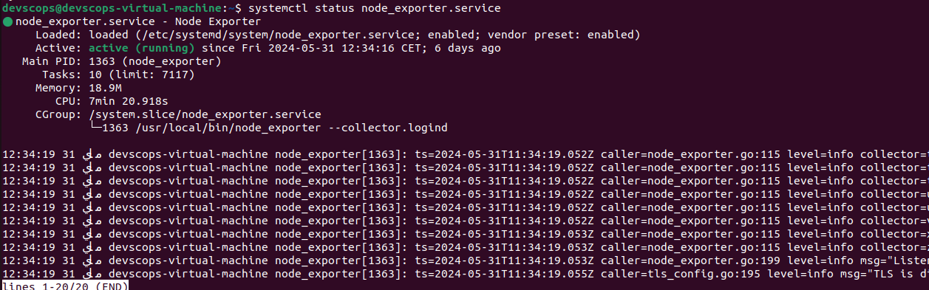sudo systemctl status node_exporter

11- sudo nano /etc/prometheus/prometheus.yml

- job_name: "node_export"

static_configs:

- targets: ["localhost:9100"]

12- promtool check config /etc/prometheus/prometheus.yml

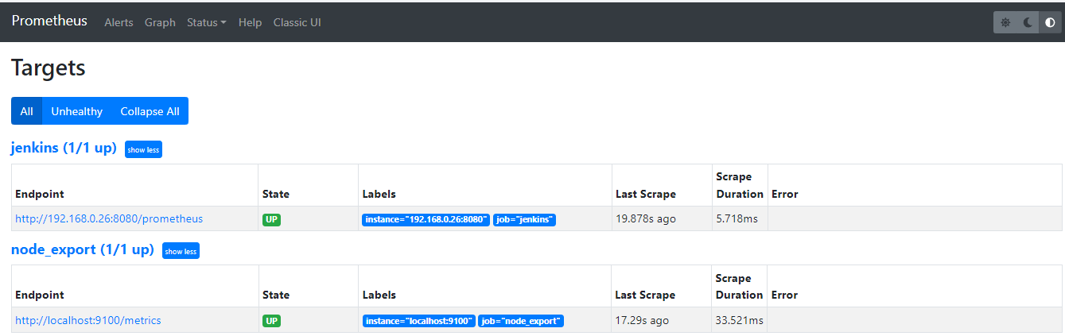

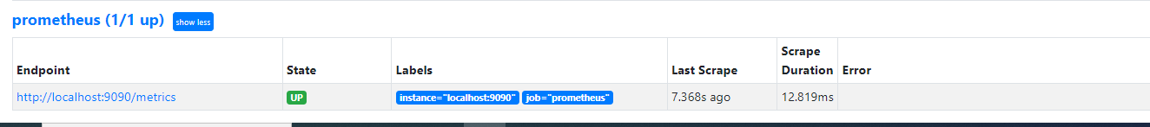

Now, install the Grafana tool to visualize all the data that is coming with the help of Prometheus.

* Grafana

1- sudo apt-get install -y apt-transport-https software-properties-common

2- wget -q -O - https://packages.grafana.com/gpg.key | sudo apt-key add -

3- echo "deb https://packages.grafana.com/oss/deb stable main" | sudo tee -a /etc/apt/sources.list.d/grafana.list

4- sudo apt-get update

5- sudo apt-get -y install grafana

6- sudo systemctl enable grafana-server

7- sudo systemctl start grafana-server

8- sudo systemctl status grafana-server

To access the Grafana dashboard, copy the public IP address of the **machine**and paste it into your favorite browser with port 3000

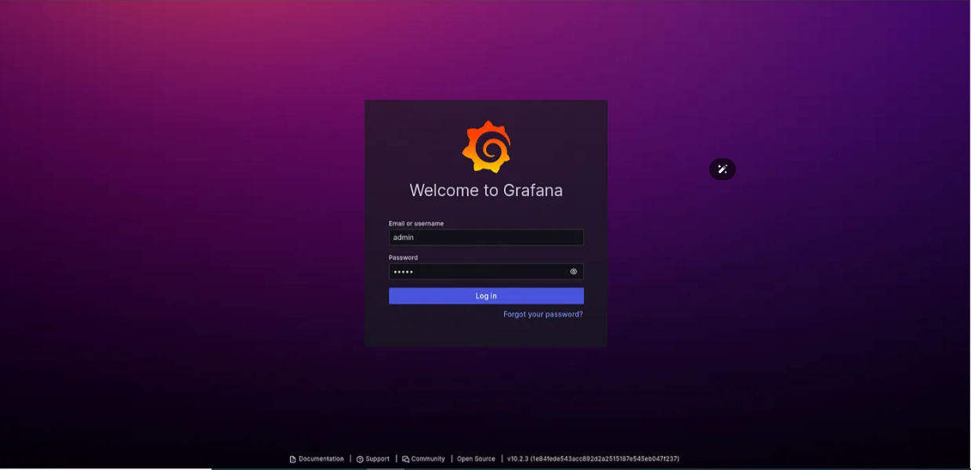username and password will be admin

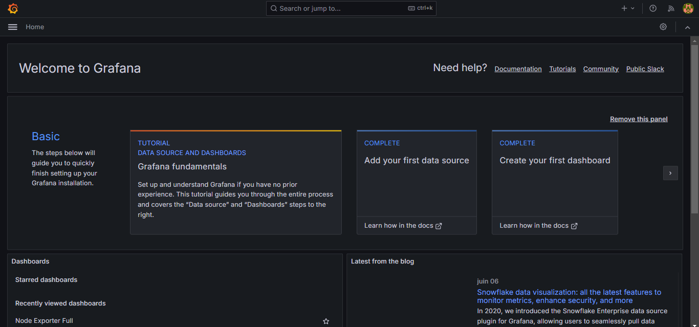

Go to the dashboard section of Grafana and click on the Import**dashboard.**

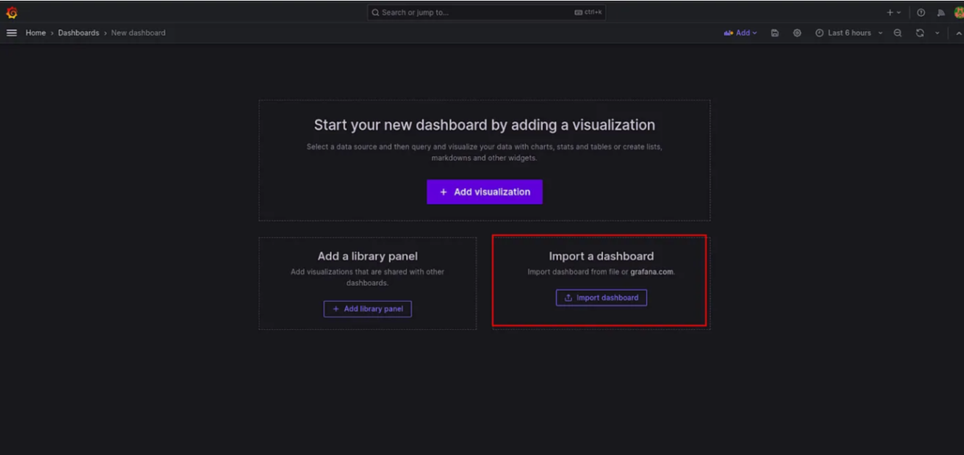

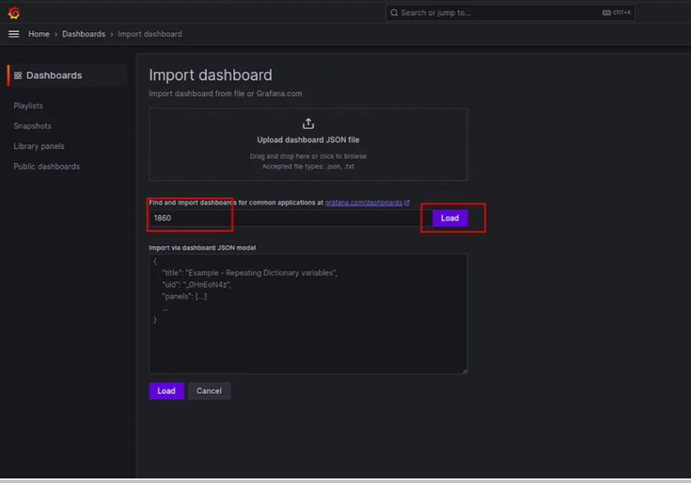Add 1860 for the node exporter .

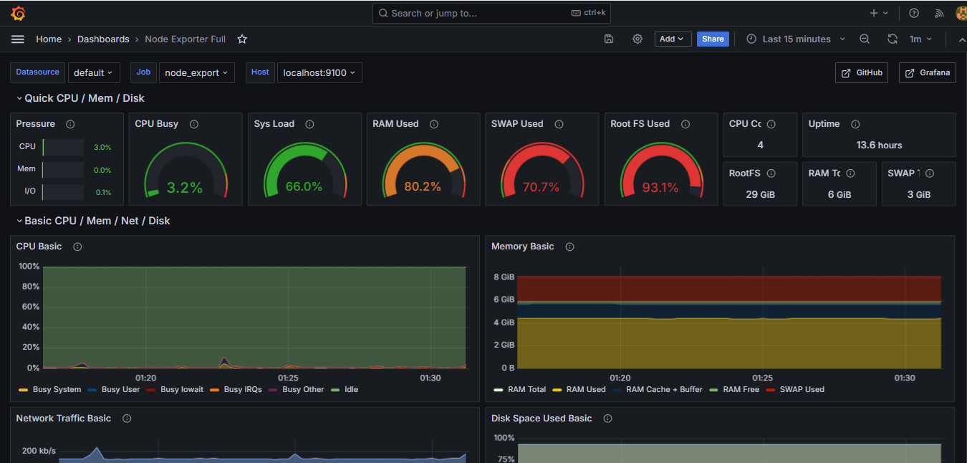Now, we have to monitor our **Jenkins Server**as well.

For that, we need to install the Prometheus metric plugin on our Jenkins.

Go to **Manage Jenkins** -> Plugin search for Prometheus metrics install it and restart your Jenkins.

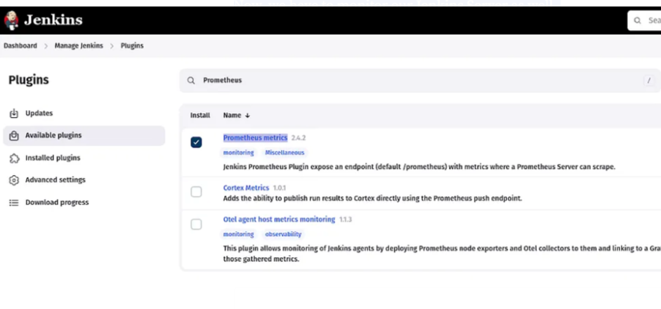

Edit the /etc/prometheus/prometheus.yml file

sudo vim /etc/prometheus/prometheus.yml

- job_name: "jenkins"  
 static_configs:  
 - targets: ["<jenkins-server-public-ip>:8080"

promtool check config /etc/prometheus/prometheus.yml

You will see the targets that you have added in the /etc/prometheus/prometheus.yml file.

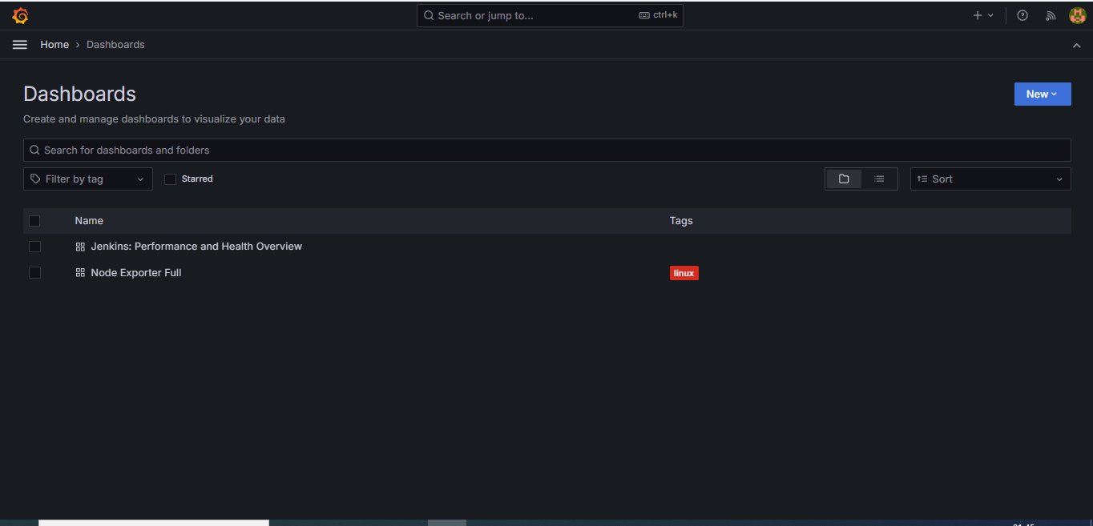To add the Jenkins Dashboard on your Grafana server.  
Provide the 9964 to Load the dashboard.

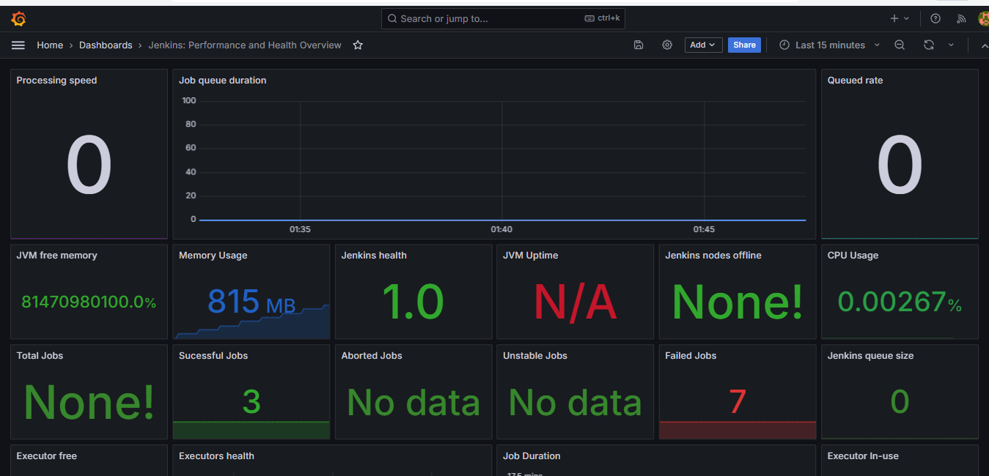You will see your Jenkins Monitoring dashboard in the below snippet.

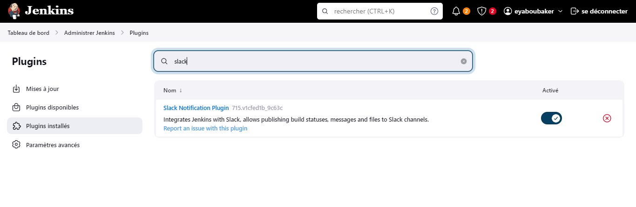Now, we have to configure slack for the alerts.

Go to Jenkins -> **Manage Jenkins**-> **System**

Search for Slack.

Provide the devscopsgroupe in the **Workspace**and the credential slack and jenkins in the default channel.

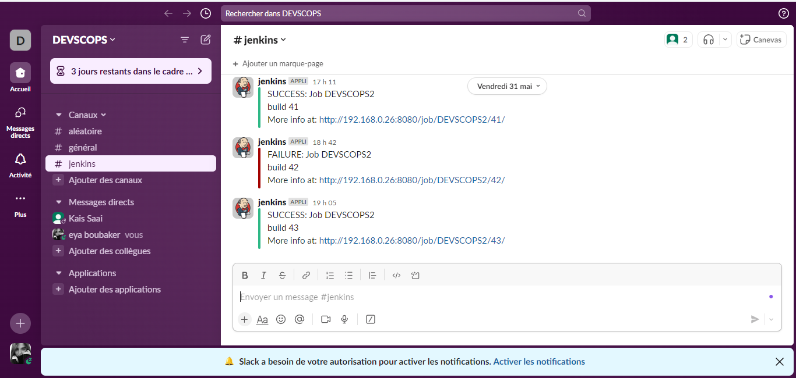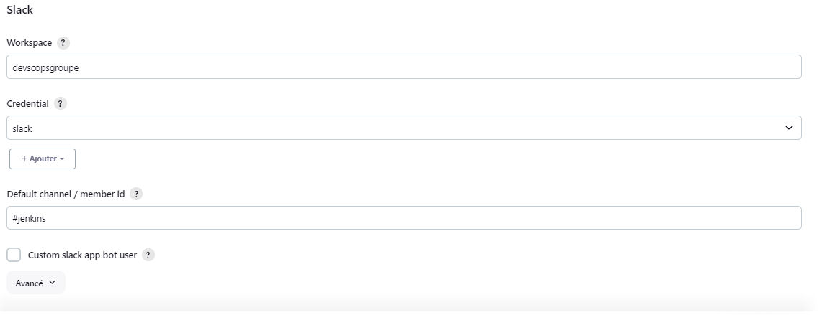You can see below for the reference.

Now, we will set up our Jenkins Pipeline. But there are some plugins required to work with them.

Download the following plugins

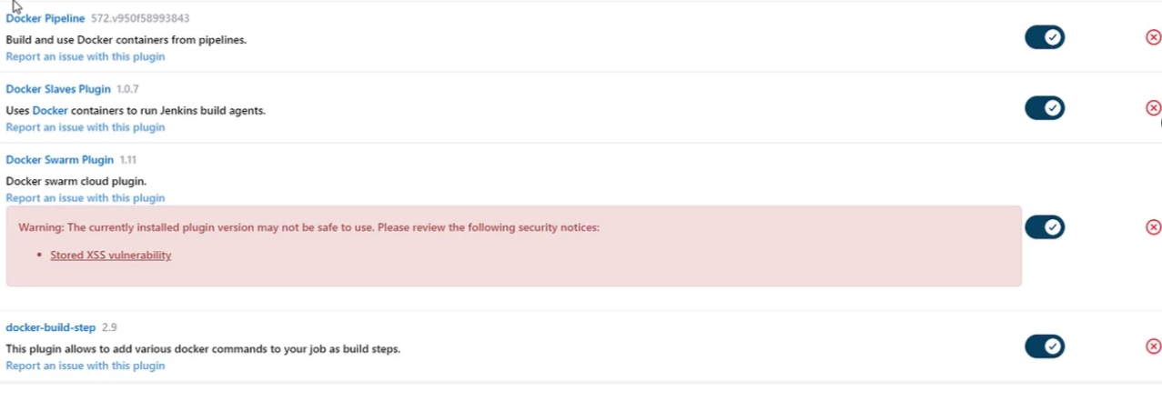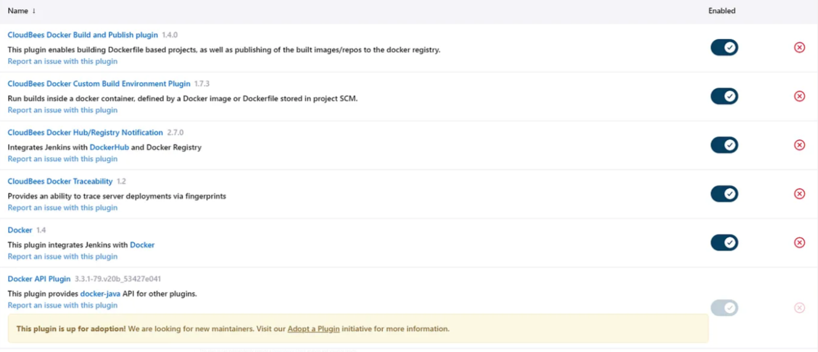

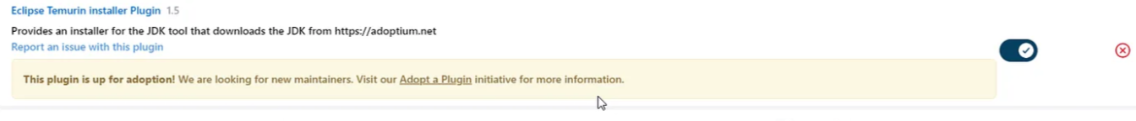

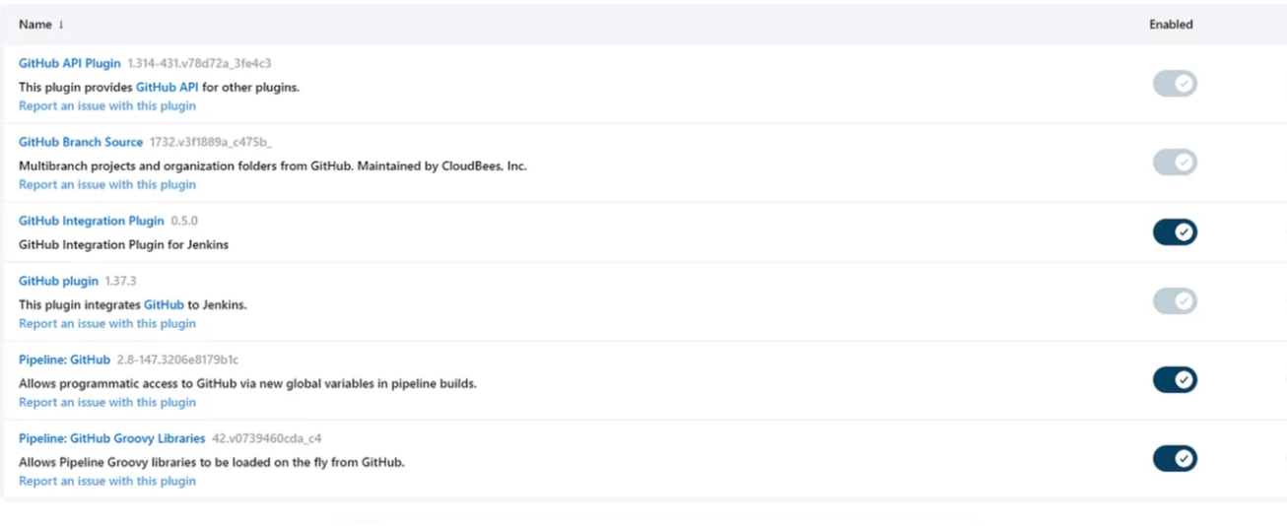Now, configure the plugins

Go to **Manage Jenkins -> Tools**

Click on Add JDK and provide the following things below

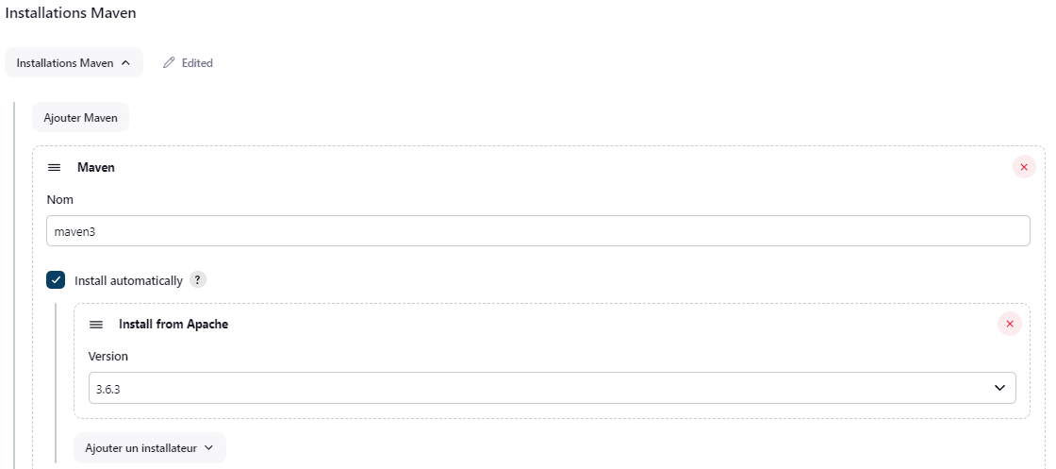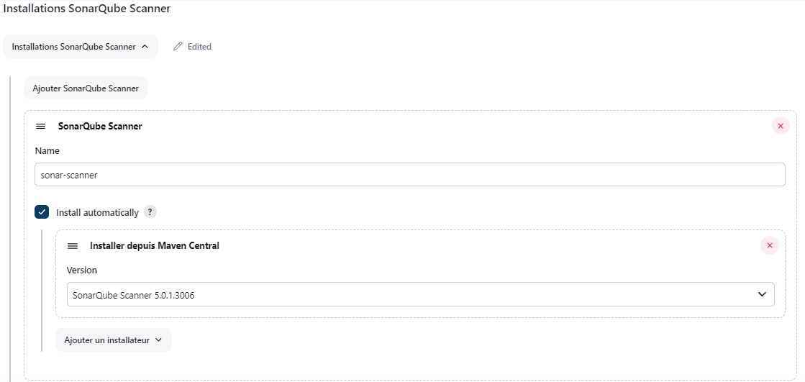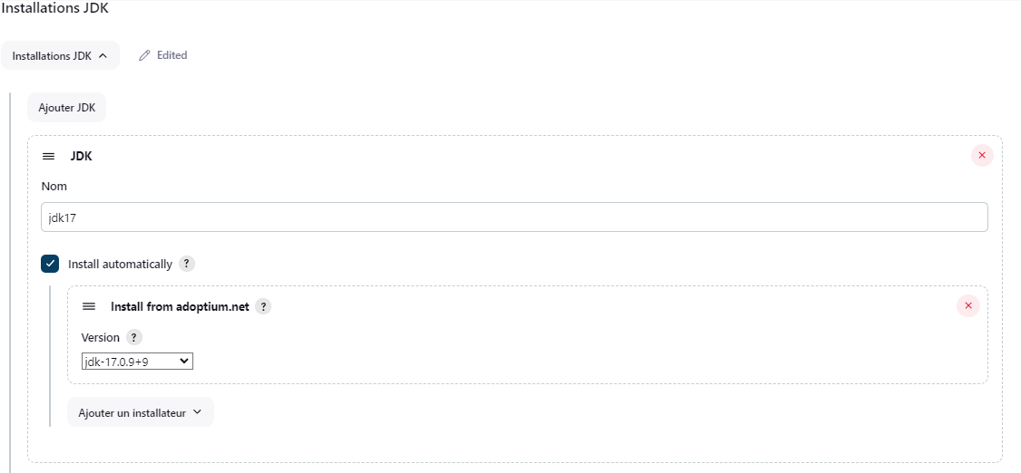

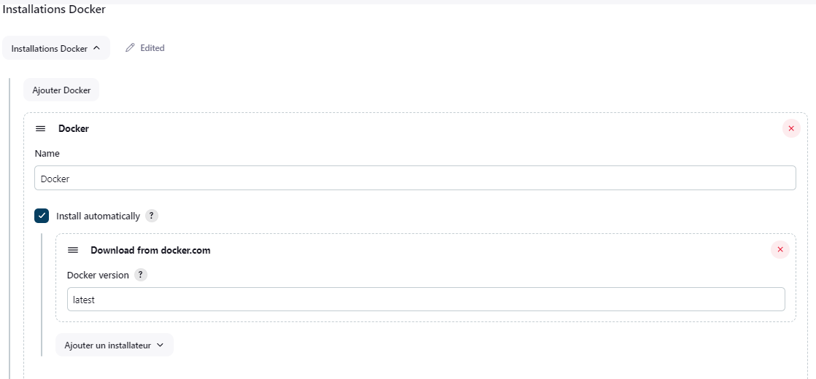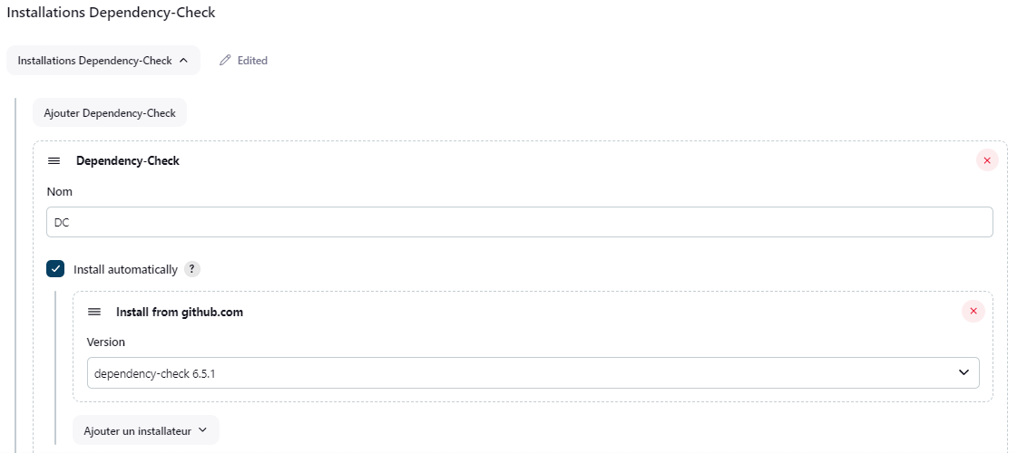

Now, we will configure Sonarqube

To access the sonarqube, copy the machine public IP with port number 9000

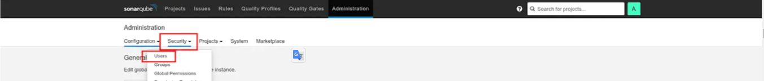Then, click **Security**and click on **Users.**

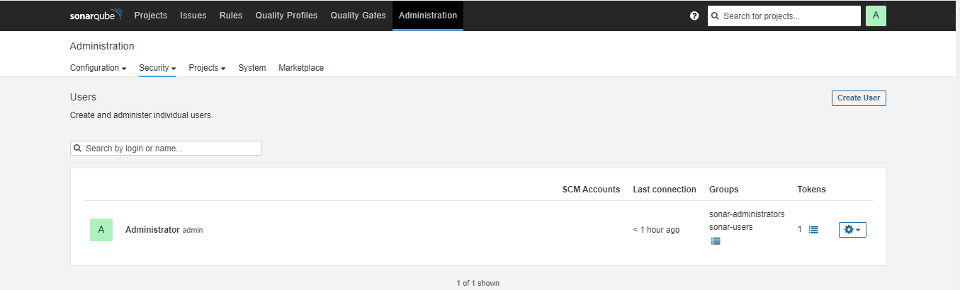Click on the highlighted blue box on the right to generate the token.

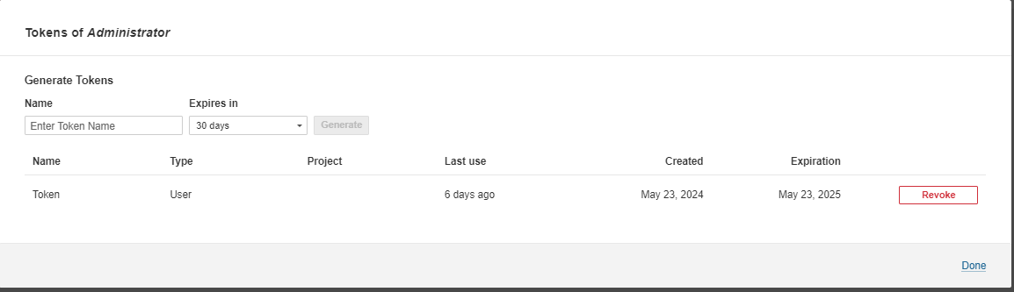

Now, add the token to your Jenkins credentials

Go to **Manage Jenkins -> Credentials.**

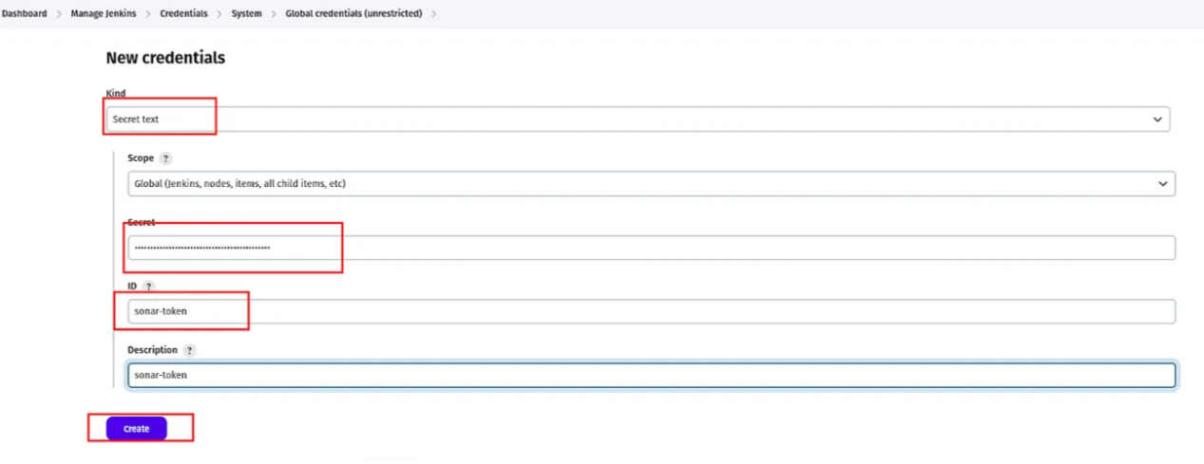Provide your token then provide the ID as sonar-token to call the credentials.

Go to **Manage Jenkins -> System**

Click on **Add Sonarqube**

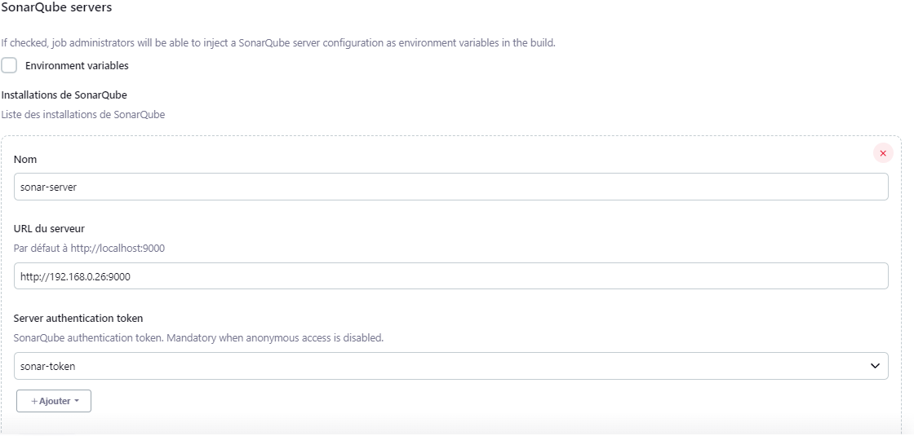Provide the name sonar-server with the Server URL and select the credentials that we have added.

Now, we have to build our Docker Image and push it to DockerHub

To do that, we need to configure the following things.

Go to **Manage Jenkins -> Credentials**

Add Docker Credentials to your JenkinsNow, we will create the Jenkins Pipeline

Click on **Create item.**

Provide the name of your Jenkins Pipeline and select **Pipeline.**

def COLOR_MAP = [

'FAILURE' : 'danger',

'SUCCESS' : 'good'

]

pipeline{

agent any

tools{

jdk 'jdk17'

maven 'maven3'

}

environment {

SCANNER_HOME=tool 'sonar-scanner'

}

stages {

stage('Checkout From Git'){

steps{

git branch: 'master', url: 'https://github.com/eyaboubaker/Devscops.git'

}

}

stage('mvn compile'){

steps{

sh 'mvn clean compile'

}

}

stage('mvn test'){

steps{

sh 'mvn test -DskipTests=true'

}

}

stage('Lynis Security Scan') {

steps {

script {

// Exécutez le balayage de sécurité Lynis et convertissez la sortie en HTML

sh 'lynis audit system | ansi2html > lynis-report.html'

// Affiche le chemin absolu du fichier de rapport dans la console de sortie Jenkins

def reportPath = "${WORKSPACE}/lynis-report.html"

echo "Chemin du rapport Lynis : ${reportPath}"

// Archive le fichier de rapport pour qu'il soit accessible après la construction

archiveArtifacts artifacts: 'lynis-report.html'

}

}

}

stage('OWASP FS SCAN') {

steps {

dependencyCheck additionalArguments: '--scan ./' , odcInstallation: 'DC'

dependencyCheckPublisher pattern: '**/dependency-check-report.xml'

}

}

stage("Sonarqube Analysis "){

steps{

withSonarQubeEnv('sonar-server') {

sh ''' $SCANNER_HOME/bin/sonar-scanner -Dsonar.projectName=EKART \

-Dsonar.java.binaries=. \

-Dsonar.projectKey=EKART '''

}

}

}

stage('Build'){

steps{

sh "mvn package -DskipTests=true "

}

}

stage('Publish To Nexus') {

steps {

withMaven(globalMavenSettingsConfig: 'global-maven', jdk: 'jdk17', maven: 'maven3', mavenSettingsConfig: '', traceability: true) {

sh "mvn deploy -DskipTests=true"

}

}

}

stage('Build & Tag Docker Image') {

steps {

script {

withDockerRegistry(credentialsId: 'docker-cred', toolName: 'Docker') {

sh "docker build -t boubakereya22/ekart:latest -f docker/Dockerfile ."

}

}

}

}

stage('TRIVY') {

steps {

script {

// Effectue le balayage de sécurité de l'image et écrit la sortie dans un fichier HTML

sh 'trivy image --format table --timeout 5m -o trivy-image-report.html boubakereya22/ekart:latest'

// Affiche le chemin absolu du fichier de rapport dans la console de sortie Jenkins

def reportPath = "${WORKSPACE}/trivy-image-report.html"

echo "Chemin du rapport Trivy : ${reportPath}"

// Archive le fichier de rapport pour qu'il soit accessible après la construction

archiveArtifacts artifacts: 'trivy-image-report.html'

}

}

}

stage('Push Docker Image') {

steps {

script {

withDockerRegistry(credentialsId: 'docker-cred', toolName: 'Docker') {

sh "docker push boubakereya22/ekart:latest"

}

}

}

}

stage('Deploy To Kubernetes') {

steps {

withKubeConfig(caCertificate: '', clusterName: '', contextName: '', credentialsId: 'k3s-cred', namespace: 'webapps', restrictKubeConfigAccess: false, serverUrl: 'https://192.168.0.8:6443') {

sh "kubectl apply -f deploymentservice.yml"

}

}

}

stage('Verify the Deployment') {

steps {

withKubeConfig(caCertificate: '', clusterName: '', contextName: '', credentialsId: 'k3s-cred', namespace: 'webapps', restrictKubeConfigAccess: false, serverUrl: 'https://192.168.0.8:6443') {

sh "kubectl get pods -n webapps"

sh "kubectl get svc -n webapps"

}

}

}

stage('Nikto Security Scan') {

steps {

script {

// Exécuter Nikto et enregistrer la sortie dans nikto-report.html dans le répertoire de travail

sh 'nikto -h https://192.168.0.9:8070 -o Nikto-report.html'

// Affiche le chemin absolu du fichier de rapport dans la console de sortie Jenkins

def reportPath = "${WORKSPACE}/Nikto-report.html"

echo "Chemin du rapport Nikto : ${reportPath}"

// Archive le fichier de rapport pour qu'il soit accessible après la construction

archiveArtifacts artifacts:'Nikto-report.html'

}

}

}

}

post {

always {

echo 'Slack Notifications'

slackSend (

channel: '#jenkins',

color: COLOR_MAP[currentBuild.currentResult],

message: "${currentBuild.currentResult}: Job ${env.JOB_NAME} \n build ${env.BUILD_NUMBER} \n More info at: ${env.BUILD_URL}"

)

}

}

}

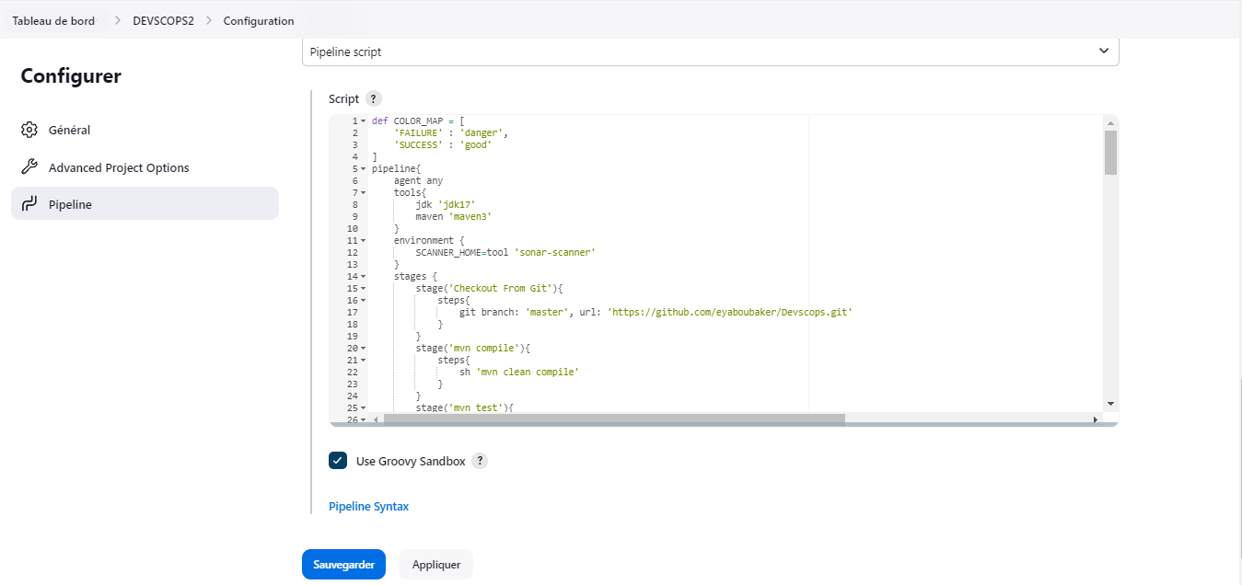

Click on build pipeline and after getting the success of the pipeline.

You will see the Sonarqube code quality analysis which will look like the below snippet.

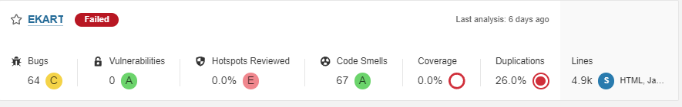

Now, click on **Build Now.**

As you can see Our Pipeline is successful.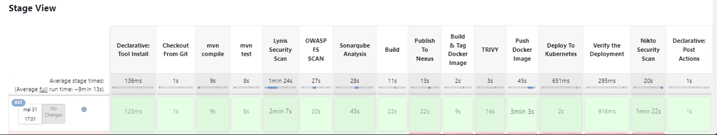

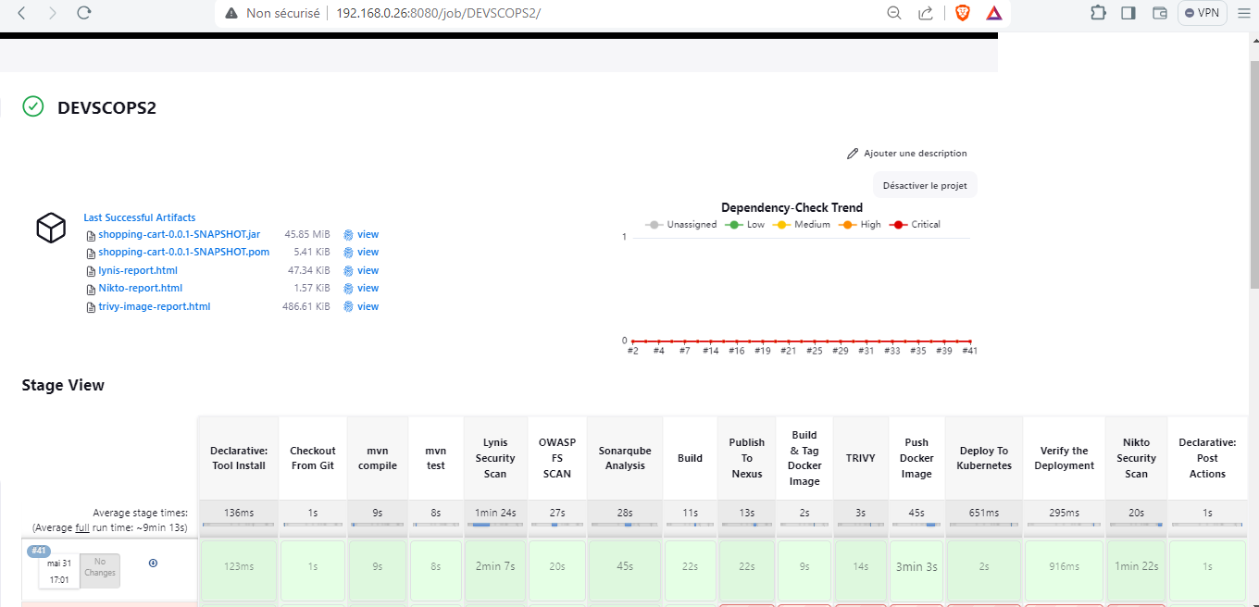

you will all the artefacts, Now, validate whether the docker image has been pushed to DockerHub or not.

As you can see in the below screenshot, Our Docker image is present on Docker Hub.

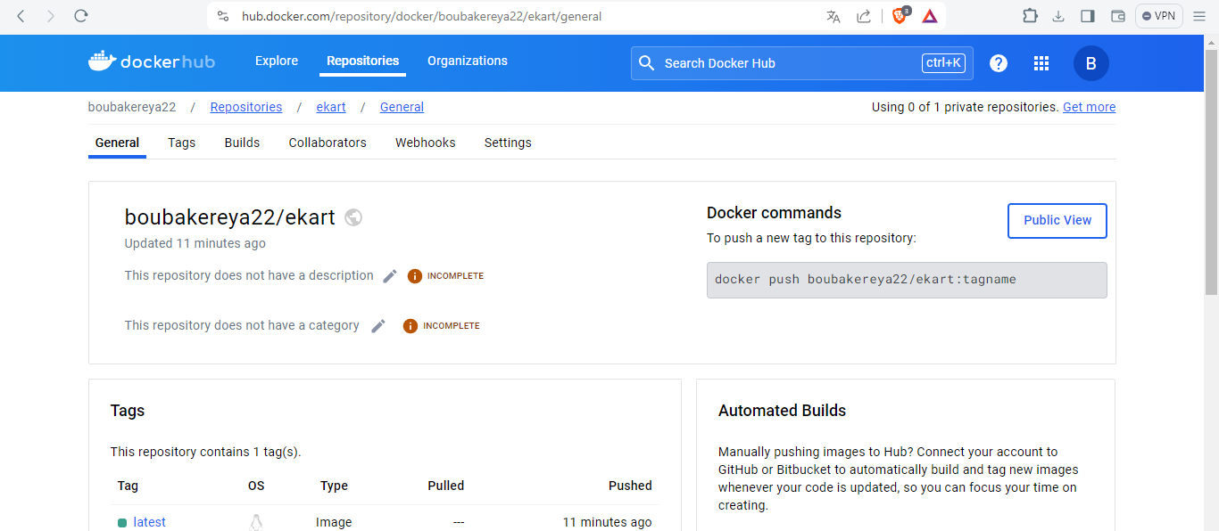

Now, we have to deploy our application using Kubernetes.

As you know, we have three Kubernetes Nodes of which one is the Master and the other are the Worker Node.

Login to your both Kubernetes Master and Worker Nodes

**Master + worker**

1- sudo apt update

2- sudo apt upgrade -y

3- sudo reboot

4-

addresses:

- @IP/24

nameservers:

addresses:

- @IP

routes:

- to: default

via: @IP_Gateway

**Master**

5- sudo hostnamectl set-hostname "k8s-master.placeholder.tn"

**worker**

6- sudo hostnamectl set-hostname "k8s-worker1.placeholder.tn"

7- sudo hostnamectl set-hostname "k8s-worker2.placeholder.tn"

**Master + worker**

8- exec bash

9- sudo nano /etc/hosts

192.168.1.10 k8s-master.placeholder.tn k8s-master

192.168.1.11 k8s-worker1.placeholder.tn k8s-worker1

192.168.1.12 k8s-worker2.placeholder.tn k8s-worker2

10- sudo swapoff -a

11- sudo nano /etc/fstab

#/swap.img none swap sw 0 0

12- sudo mount -a

13- free -h

14 - sudo tee /etc/modules-load.d/containerd.conf <<EOF

overlay

br_netfilter

EOF

15- sudo modprobe overlay

16- sudo modprobe br_netfilter

17- sudo tee /etc/sysctl.d/kubernetes.conf <<EOF

net.bridge.bridge-nf-call-ip6tables = 1

net.bridge.bridge-nf-call-iptables = 1

net.ipv4.ip_forward = 1

EOF

18- sudo apt install -y curl wget

/// Master

19- curl -sfL https://get.k3s.io | sh -

20- sudo systemctl status k3s

21- mkdir ~/.kube

22- sudo cp /etc/rancher/k3s/k3s.yaml ~/.kube/config && sudo chown $USER ~/.kube/config

23- sudo chmod 600 ~/.kube/config && export KUBECONFIG=~/.kube/config

24- curl -sfL https://get.k3s.io | INSTALL_K3S_EXEC="--flannel-backend=none --disable-network-policy --cluster-cidr=10.10.0.0/16" sh -

**Master**

25- sudo cat /var/lib/rancher/k3s/server/node-token

**Worker**

26- curl -sfL https://get.k3s.io | K3S_URL=https://serverip:6443 K3S_TOKEN=mytoken sh -

**Master**

27- kubectl create -f https://raw.githubusercontent.com/projectcalico/calico/v3.28.0/manifests/tigera-operator.yaml

Both nodes are ready.

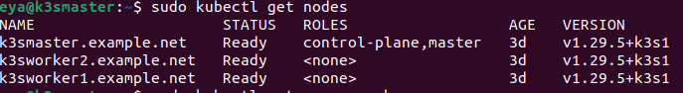

Now, we will set Kubernetes Monitoring for both Master and worker Nodes

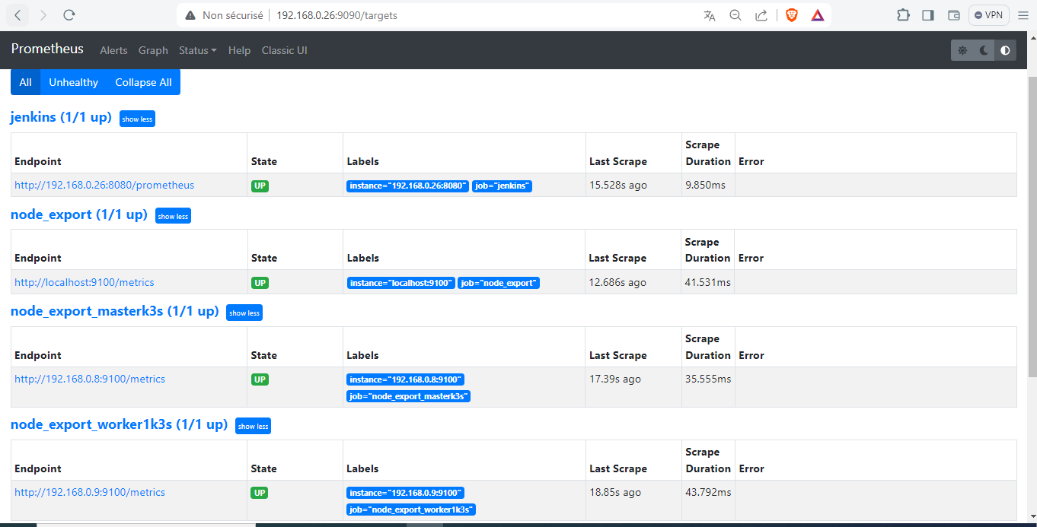 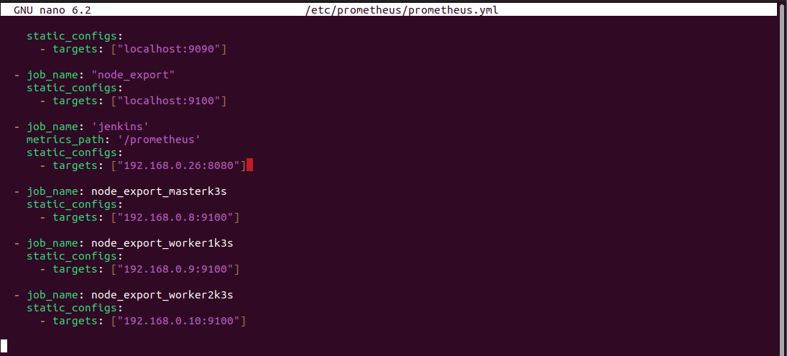

Click on **Add credentials.**

You can validate whether your pods are running or not from your Kubernetes master node.

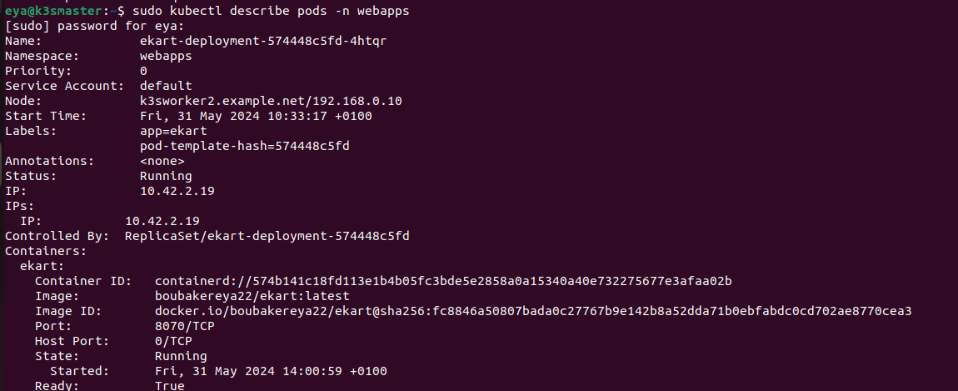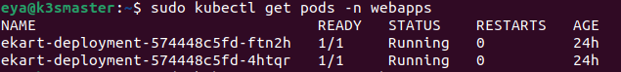

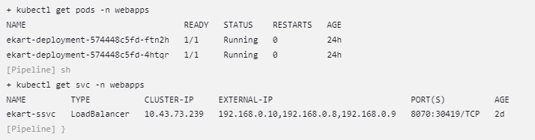Also, you can check the Console logs for the earlier results.

We got a notification in slack that our pipeline was successful.



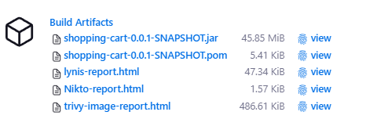

we got the vulnerabilities for our Docker Image.

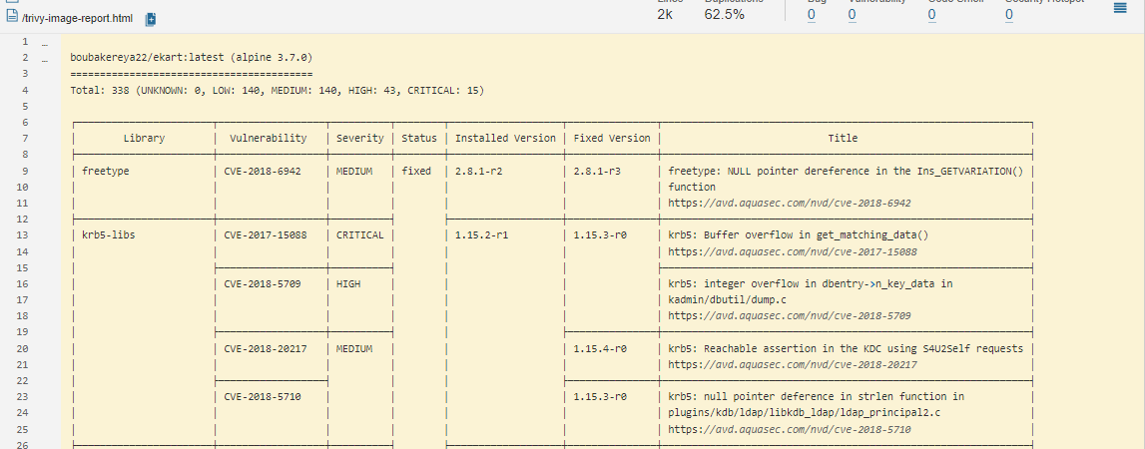

Go to the Grafana Dashboard and select Node Exporter.

You will see the real-time hardware specs of your Kubernetes master node.

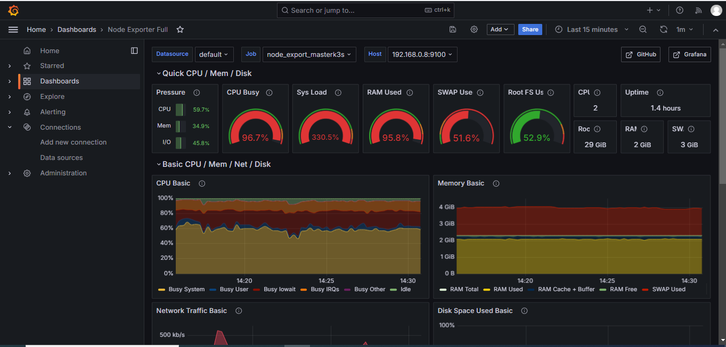

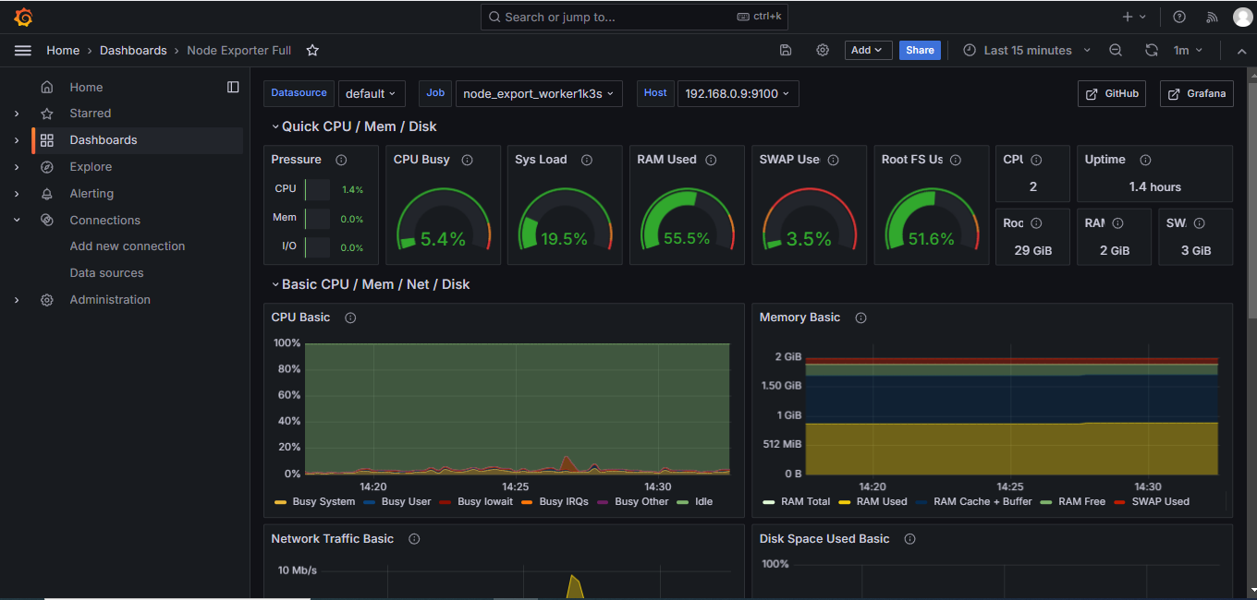You will see the real-time hardware specs of your Kubernetes worker node.

Copy the Public IP of Worker Node and paste it on your favorite browser with port 8304 and see the magic.

